**COIT20245- Introduction to Programming**

**Assignment 2-Term 2, 2019**

Lecturer: Ahmedi Azra

Tutor: Aries Tao

Prepared By:

Bishal Budhathoki

12116421

**UML ACTIVITY DIAGRAM OF OPTION 2:**

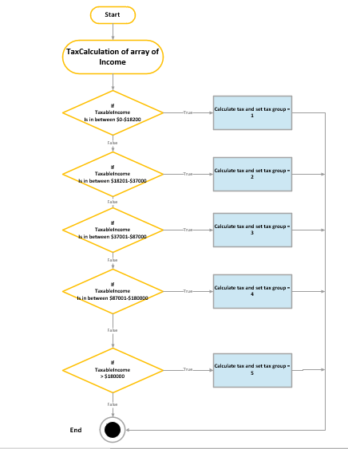

Figure 1: UML Activity diagram for menu option 2

**Output:**

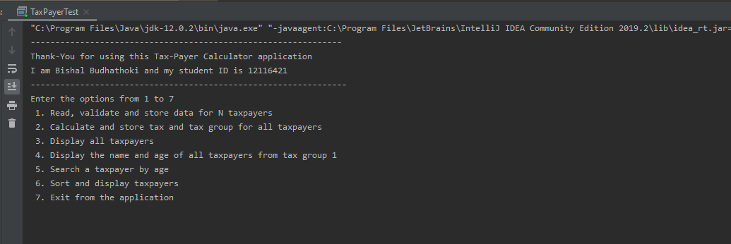Figure 2: Welcome Message

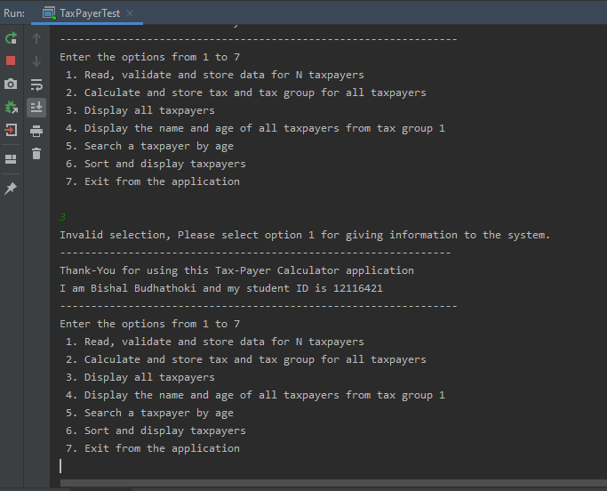

Figure 3: Error message when entering another option different than 1 at beginning

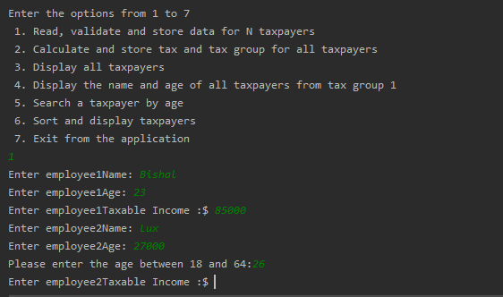

Figure 4: Age entered wrong and is handled with an error message

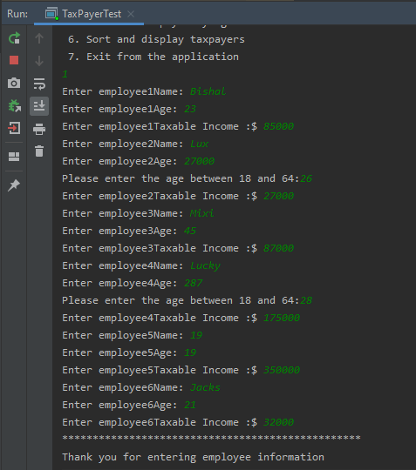

Figure 5: User input read and stored in array

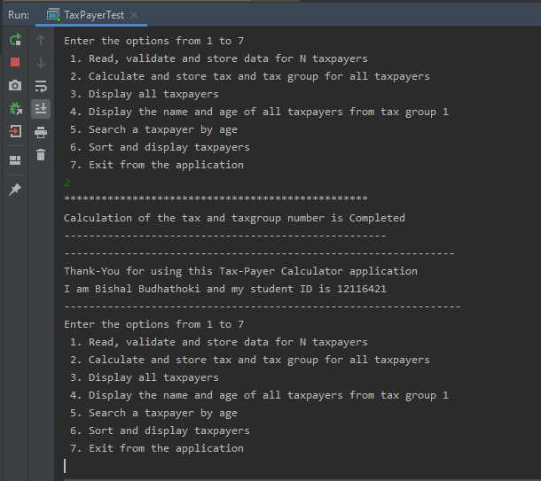Figure 6: Calculation of tax and tax group number when option 2 is selected

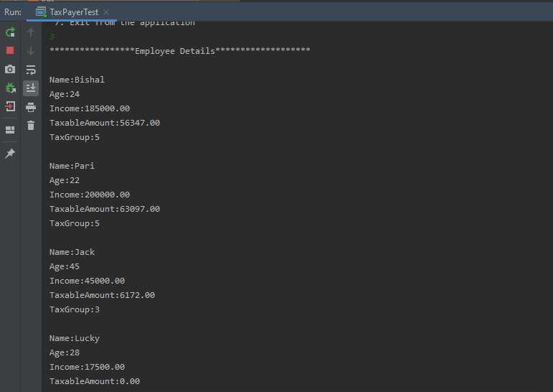

Figure 7: Display user input along with their tax group when option 3 is selected

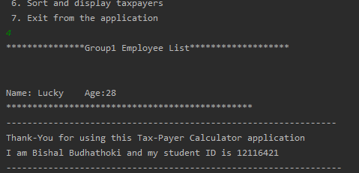

Figure 8: Display group 1 Name and age data when option 4 is selected

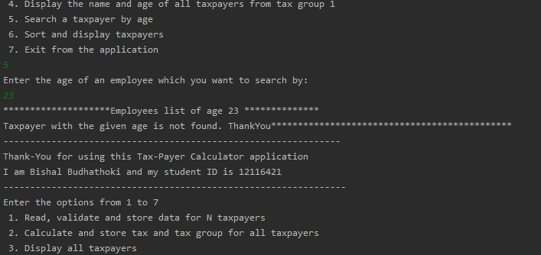

Figure 9: Search taxpayer by age but not found when option 5 is selected

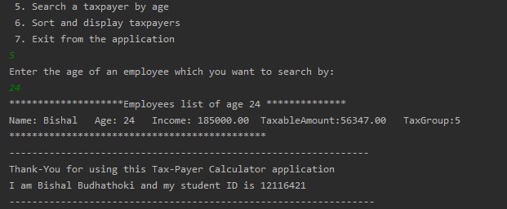

Figure 10: Search taxpayer by age and found when option 5 is selected

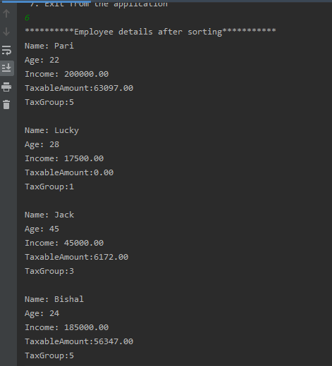

Figure 11: Sort and display the user input taxpayer in descending order of name when option 6 is selected



Figure 12: Display message to provide correct taxable income amount

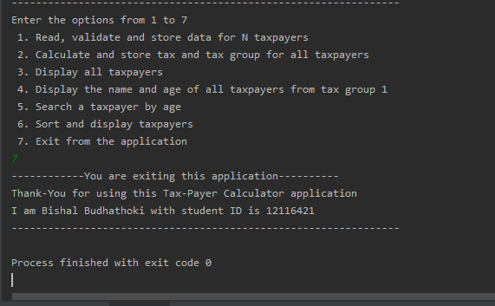

Figure 13: Display exit message

**Thank-You**